**Sites**

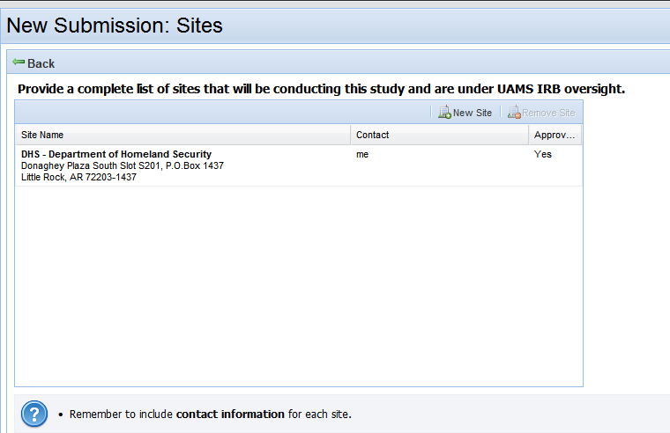

Help Text:

Add text, “If single site, enter the requested information for that site.”